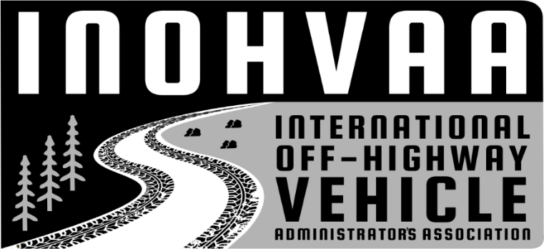
2025/2026
Mission: To facilitate collaboration, cohesion, and cooperation between international off-highway vehicle agencies, stakeholders, and enthusiasts.

INOHVAA Members and Partners, My name is Peter Reed. I currently serve as Board Chair for the International Off-Highway Vehicle Administrators Association (INOHVAA) and V.P. of the Canadian Quad Council (CQC).
For those that are new or unfamiliar with INOHVAA, our organization works to bring together OHV program managers, motorized grant administrators, and our partners from across the United States and North America to collaborate on best OHV management practices; safety, ethics, and education; and uniformity of rules and regulations in an effort to minimize impacts and develop strong partnerships between OHV agencies, land managers, and the recreating public.!
This October, we will again be partnering with the National Off-Highway Vehicle Conservation Council (NOHVCC) to host our joint annual conference in Bend, Oregon, from October 8th to the 11th at the RiverHouse Lodge, Bend, Oregon. For further information, review the NOHVCC website.
This year’s INOHVAA Annual General Meeting and NOHVCC conference will continue to facilitate the collaborative growth we experienced last year. We again plan to have a variety of diverse breakout sessions on engaging topics designed to improve communication and promote growth between off-highway vehicle administrators, industry partners.
Our board has created an agenda for the AGM that we’ll host on Wednesday, October 08, 2025, followed by the mobile workshop on Thursday, and the remaining conference sessions on Friday and Saturday. We’ll close out the conference with a joint awards dinner and ceremony on Saturday evening. Please feel free to share our Annual Meeting Agenda and Schedule of Events with anyone you think may be interested in joining INOHVAA or attending the conference! We look forward to meeting with you in October. If you have any questions, please feel free to contact me at the information provided below. Take care and ride safely.

Peter Reed
________________________________
INOHVAA Board Chair
CQC V.P. preed304@gmail.com
403-990-8904

