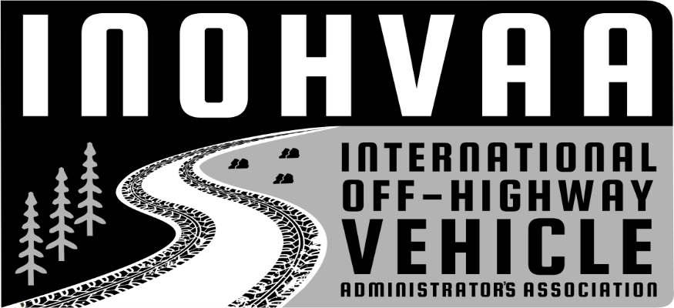
2025/2026
Mission: To facilitate collaboration, cohesion, and cooperation between international off-highway vehicle agencies, stakeholders, and enthusiasts.

NOTICE OF MEETING

of
The International Off-Highway Vehicle Administrators Association (INOHVAA)

Notice is hereby given to members of the International Off-Highway Vehicle Administrators Association (“INOHVAA”). This October, we will again be partnering with the
National Off-Highway Vehicle Conservation Council (NOHVCC) to host our joint annual
conference in Bend, Oregon, from October 8th to the 11th at the RiverHouse Lodge, Bend, Oregon, call them at 541-389-3111
AGENDA

(The Chair reserves the right to set the order of the agenda.) Annual General Meeting that we’ll host on Wednesday, October 08, 2025, at 5 pm at the RiverHouse Lodge, Bend, Oregon.

This will be a round table meeting with an opportunity for each member state or organization to showcase their organization. The bulk of the AGM will take place during this session with voting for board members later in the conference.

- Wednesday, October 08, 2025 CALL TO ORDER @ 5 pm

- MEMBER ROLL CALL

- AGENDA ITEMS

  - Board update (Presenter: Peter Reed, Board Chair)
    - INOHVAA Board Chair, Peter Reed, will provide attendees with an update on the organization and the priorities of this meeting.

  - Approval of Minutes of June 2025 Quarterly Meeting.
The organization will consider and may take action to approve minutes from the June 2025 Quarterly Meeting.
  - Financial report (Presenter: Scott Morell)
    - Current Bank account and expenditures
    - Invoicing and accepting payment issues.
    - Addition of a paid position to help with issuing invoices and minutes.
    - Addition of a central mail box

  - INOHVAA By-Laws Overview. (Presenter: Bruce Lawrence, Member at Large)

Bruce Lawrence will review the web portal and the online questionnaire
INOHVAA Members are encouraged to access the By-Laws on the INOHVAA website before the meeting.
Request for information to be shared via the website.

  - Next Steps (Peter Reed) The immediate need for Board members!
Excerpt from the current Bylaws

Section 3. The primary duties of the Officers are as follows:
- Chair: provides direction to the organization; presides over regularly scheduled meetings and any emergency meetings of the organization; chairs the Executive Board; and creates meeting and conference agendas.
- Co-chair: member of the Executive Board; presides over meetings and the Executive Board in the absence of the Chair, and assists with the creation of meeting and conference agendas.
- Secretary-Treasurer: keeps the minutes and official documents of the organization; creates and manages the budget; manages and reports on the organization’s finances; and serves as a member of the Executive Board.
- Member-at-Large; represents members of the organization to the Executive Board.

  - The current Board recommends splitting the Secretary-Treasurer position into 2 separate positions.

  - Peter Reed will retain the Chair position
  - Scott Morrill wishes to relinquish the Treasurer's position
  - Forrest Kamminga will retain the Vice chair position
  - Troy Withers will retain the Member at Large position
  - Bruce Lawerance will relinquish his Member at Large and webmaster position.

Positions that require new members.
  - Treasurer
  - Web Master
  - Member at Large
  - Secretary

The organization will discuss building committees, logistics, and membership onboarding.

  - FUTURE AGENDA ITEMS
    - Members may identify items or issues they wish to be considered for inclusion on a future agenda.
    - Next steps;
    - Who are we?
    - Why do we exist?
    - Where do we go from here?
    - What can we do to make your job easier?
    - Do we need quarterly meetings? Will a meeting twice a year be sufficient?

- Quarterly General Meetings
Wednesday, January 14, 2026
Wednesday, March 18, 2026
Wednesday, June 17, 2026

  - ADJOURNMENT
A thank-you to NOHVCC for use of the meeting room and for allowing INOHVAA to meet during their conference.

  - THURSDAY, OCTOBER 09, 2025

- National Off-Highway Vehicle Conservation Council Mobile Workshop 7:00 a.m. to 6:00 p.m.

